Exercise Session One

* Open a demo project
* Create a layout, grouped by NRM2 and having all the below fields
* 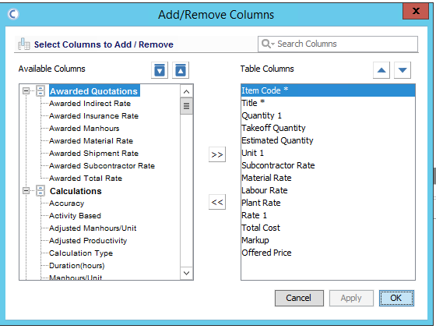
* Save the layout as “Basic NRM2 with quantities User XXXX” and make it public to the others